Turning off the modem’s speaker 2

Turning off the modem’s speaker

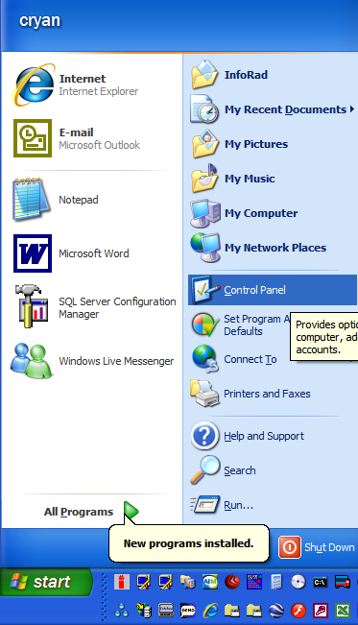
Under the Start menu (in Windows), select the Control Panel.

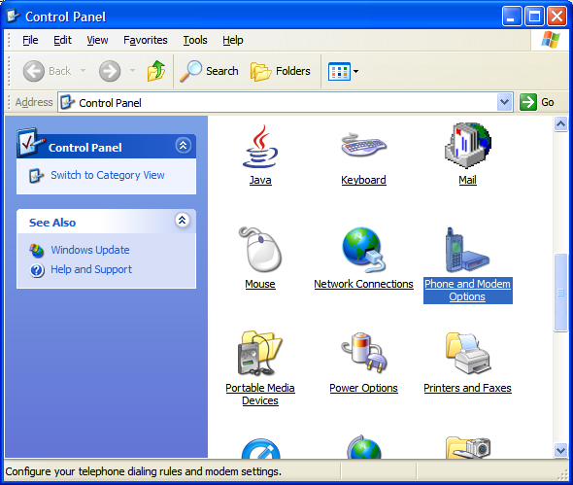
Double click on the Phone and Modem Options
(You may have to switch to Classic View first)

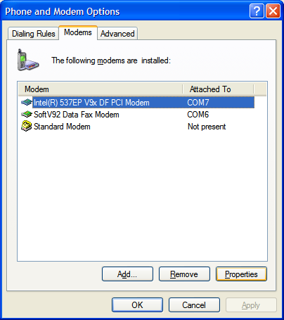
Under the Modems tab, select the appropriate modem and click on the Properties button near the lower, right.

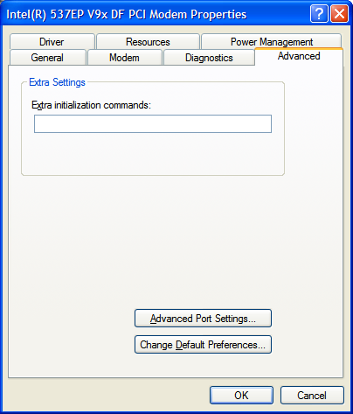
Under the Advanced tab, you have a box to enter “Extra Initialization commands.”

Try entering “M0” (without quotes) to turn off the modem’s speaker.

NOTE: This should only work if you have the InfoRad software selected to use the system’s modem configuration, found under Setup, Communications.

