 Cell Phones – via Internet email (SMTP)
This document shows you how to setup the InfoRad software to send text messages to cell phones via Internet email (SMTP).
(Note – for printing, make sure to set the Page to landscape under File, Page Setup, Paper Size tab)

Begin

Step 1. Click Edit and select Receivers |  | Next Step
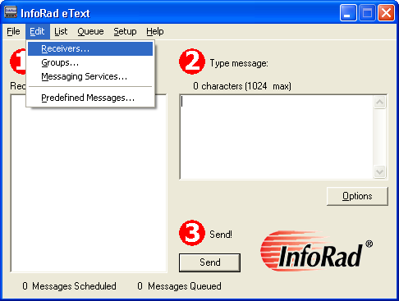
Click Edit and select Receivers

 |  | Top

Step 2. Click the New button to add a new Receiver | Prev Step | Next Step
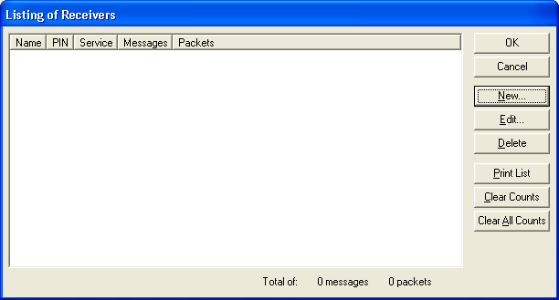
Click the New button to add a new Receiver

 |  | Top

Step 3. Enter the Receiver information as shown  Enter whatever you’d like for the “Name of the person carrying this receiver” and enter the appropriate Receiver ID (Ie. XXX5551212@messaging.sprintpcs.com for Sprint/Nextel Hybrids, or XXX5551212@cingularme.net for Cingular or XXX5551212@vtext.com for Verizon phones) “Receiver’s ID number or E-mail address” | Prev Step | Next Step
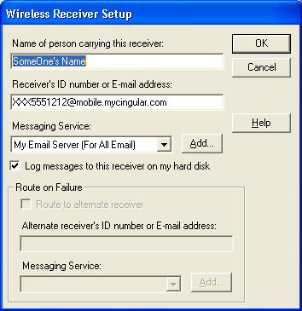
Click the Add button.
Refer to our website for other Cellular and Paging Company email address formats:
http://www.inforad.com/techsupport/MessagingServices/NoServ_MessagingServicesIndex.php3

 |  | Top

Step 4. Enter the Messaging Service information as shown | Prev Step | Next Step
D. Enter a meaningful name for the Name of the Messaging Service

Enter 140 for the Max message length

For “Send messages via” click to select “Internet e-mail (SMTP)”

Enter your email server address (Ie. outgoing-email.smtp.com) for the “E-mail Server”
NOTE: This is only an example. Contact your local IT/IS department or Internet Service Provider for the required outgoing SMTP server to use.

Normally, the port number is 25 and does not require SSL (for version 10.2 released 4/16).

If necessary, Check SMTP Authentication and enter your Account name (usually an email address) and password.

Once all information is entered accurately and completely, click the OK button.
Contact your Local IT/IS Dept or Internet Service Provider (ISP) for accurate information
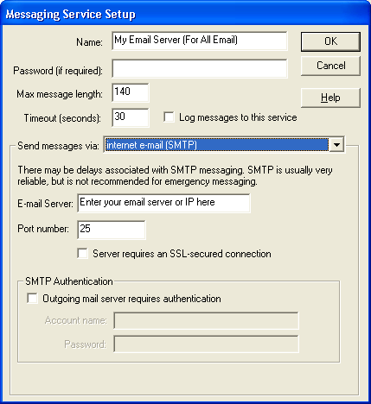

 |  | Top

Step 5. Click OK for the Wireless Receiver Setup window | Prev Step | Next Step
Click the OK button for the Wireless Receiver Setup window to accept the new Receiver using the newly entered Messaging Service

 |  | Top

Step 6. Click OK for the List of Receivers window | Prev Step | Next Step
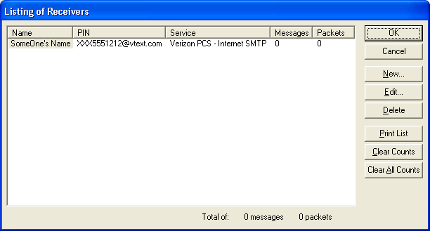
Click the OK button for the Listing of Receivers window to accept the new Receiver

 |  | Top

Step 7. Click Setup and Select Internet Settings | Prev Step | Next Step
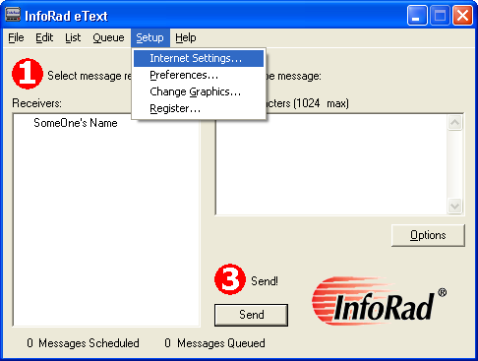

 |  | Top

Step 8. Click on the ReplyTO Address tab and enter your email address. Click OK. | Prev Step | Next Step
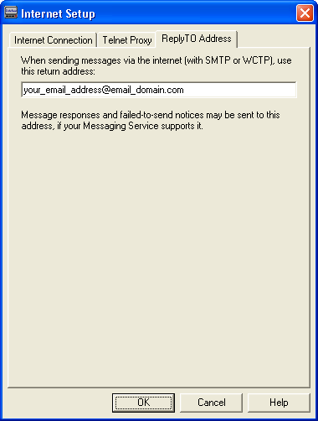

 |  | Top

1. Click on the Receiver
2. Enter a message to send
Step 9. Send a test page | Prev Step | Next Step
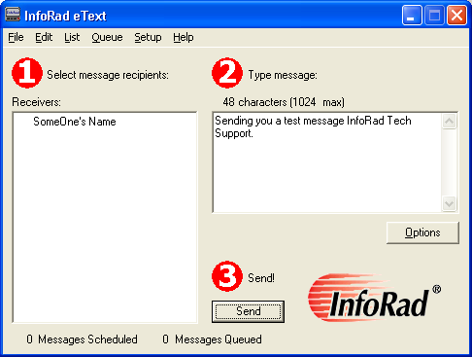
3. Click the Send button or press Enter on the keyboard to send the page.

 |  | Top

Step 10. Any errors? Yes / No | Prev Step
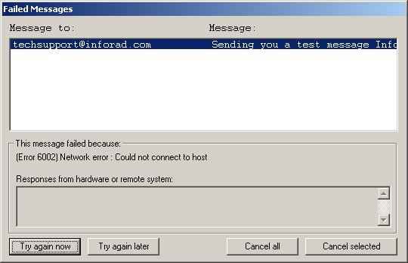
Did you receive any failed message errors? Yes / No

 |  | Top

Step 11. Helpful Tips? | Prev Step
- Check your email: In Step 7, you entered your email address. You can check your email to see if there were any emails returned to you. For instance, if you entered an incorrect email address (XXX5551212@vtext.com was not entered correctly for the Receiver’s ID to whom you’re sending the message), then sometimes the email server will respond back to your ReplyTo email Address to let you know.

- Make sure the message got to the phone.

- Note the probability of delays: Many email servers today are troubled by the problems of Spam and viruses. Email servers sometimes have the job of filtering out large amounts of Spam. Therefore, it is possible that your text message must wait for a large amount of Spam to be processed before your text message can be processed and sent to the appropriate cell phone email server.

