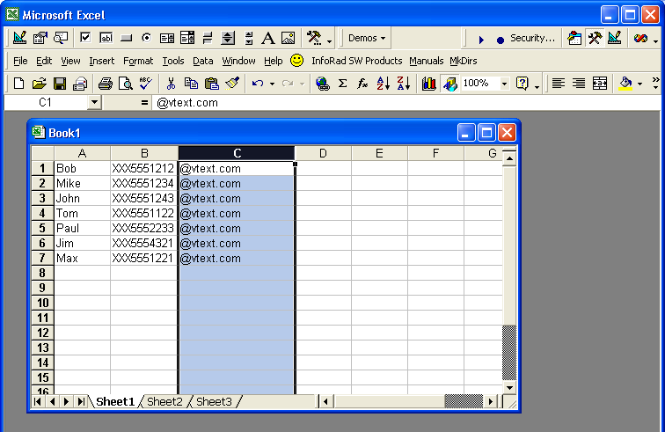
Create an Excel spreadsheet where the first column consists of all the names, the second column consists of all ten-digit phone numbers (do not use dashes, spaces, or parentheses), and the last column consists of the appropriate email address domain of the cellular company for the phone.

NOTE: Make sure to use something like the following for Column A

First
First Last
Last First

To speed things up, if you group the phones by similar cell companies, or make individual sheets according to the cell company, you can then drag and fill the cell company name down the column, then merge the sheets together.

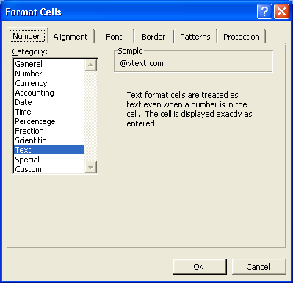
Make sure to change column C to use Text formatting so it does not try to manipulate the email domains (Ie. @vtext.com)

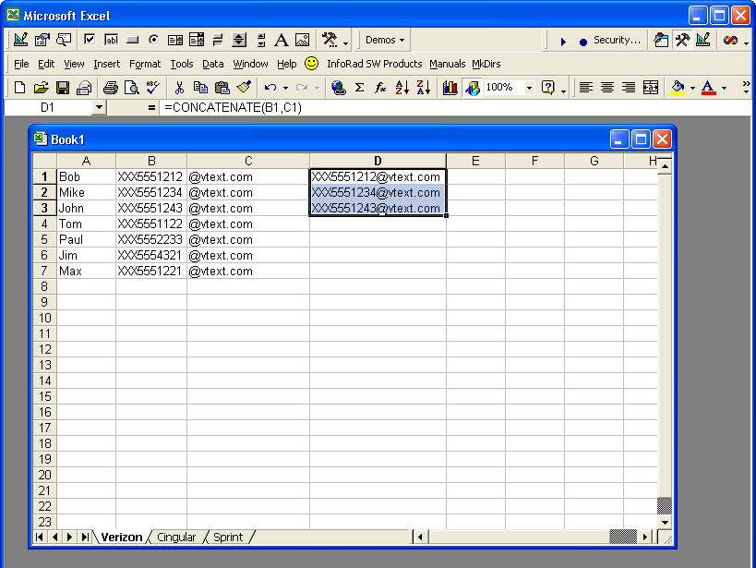
Once you have all numbers and email domains entered, you can quickly concatenate both the B column and C column together.

Enter “=CONCATENATE(B1,C1)” for D1, then Drag and Fill down for the remaining.

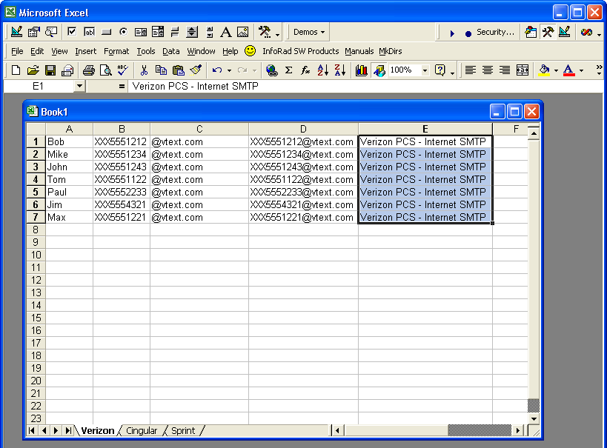
For Column E, you can Enter the Name of the Messaging Service to be used (Ie. Verizon PCS – Internet SMTP). Make sure to spell it exactly as it would show in the InfoRad software under Edit, Messaging Services (letter for letter).

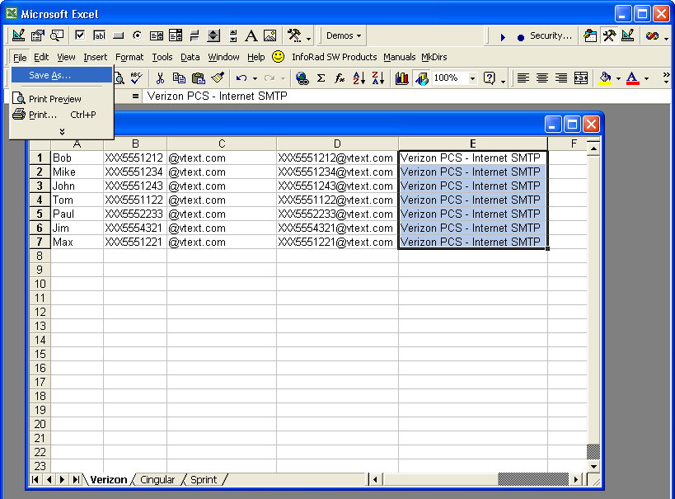
Now that all fields are done, you can Save your Excel spreadsheet as a comma-delimited, text file (CSV).

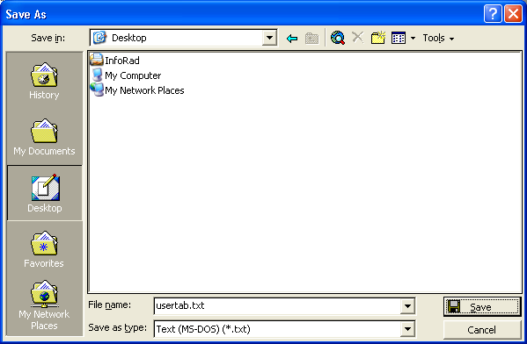
Save it to some familiar location, such as the Windows Desktop and give the filename something like usertab.txt.

Take a note that when saving as a Text file, Excel does not support multiple sheets. So you’ll need to copy and paste all sheets to one prior to saving.

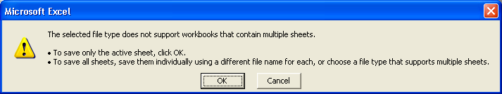

Excel also cautions you about compatibility options, so make sure you save your Workbook as an Excel document to prior to closing.

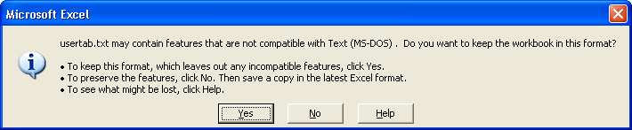

Finally, Click File, Open, and change the Files of Type to All Files (*.*) at the bottom. Select the usertab.txt file and click Open.

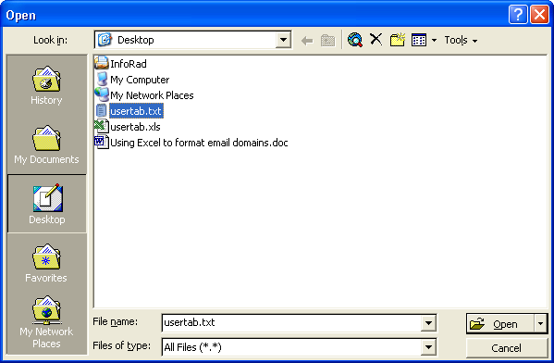

Excel will recognize that you are attempting to open a delimited file.

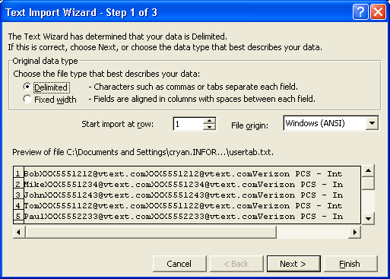

In this case, Excel saved the delimited file as a Tab-Delimited file. While it is ok to use a Tab-Delimited file at this point, make sure to save the final usertab.txt file as “Comma-Delimited” so that InfoRad’s txt2irt.exe utility can recognize and parse the file properly.

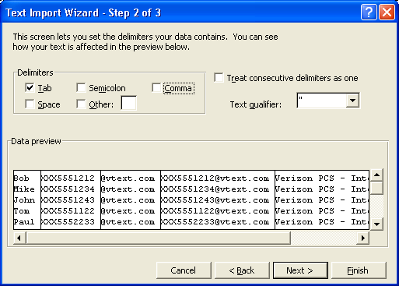

Change all columns to Text and Click Finish.

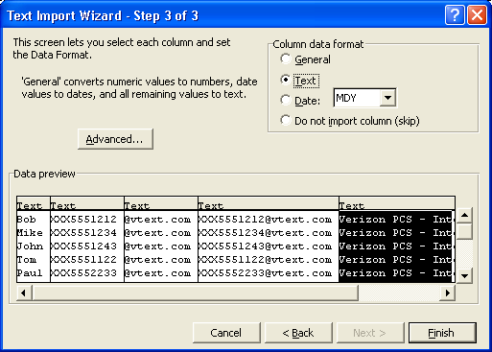

Now, the formula column has been converted to data. You can remove columns B and C, keeping columns A, D, and E for your usertab.txt file.

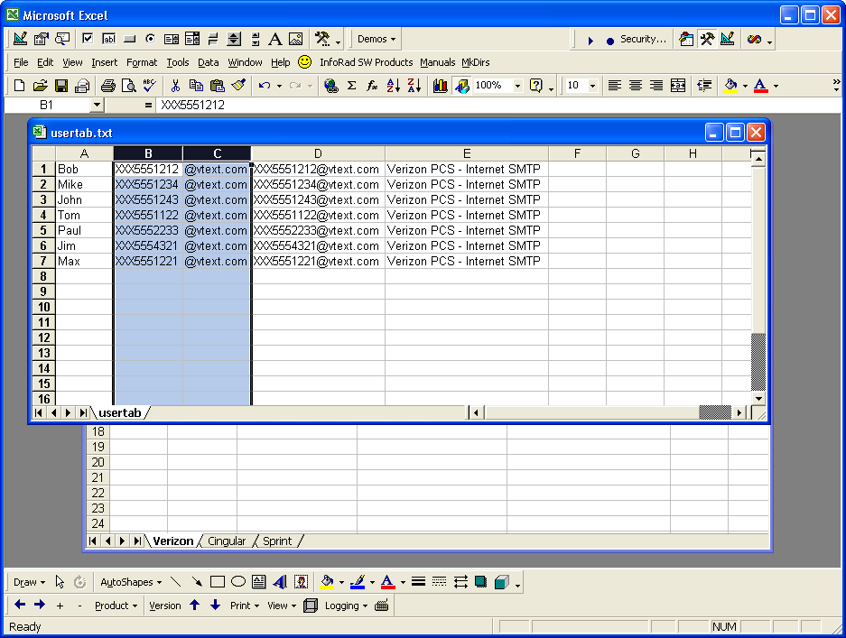

You now have Column A (List of Names), Column B (List of Email Addresses of cell phones), and Column C (Name of Cellular Company / Messaging Service)

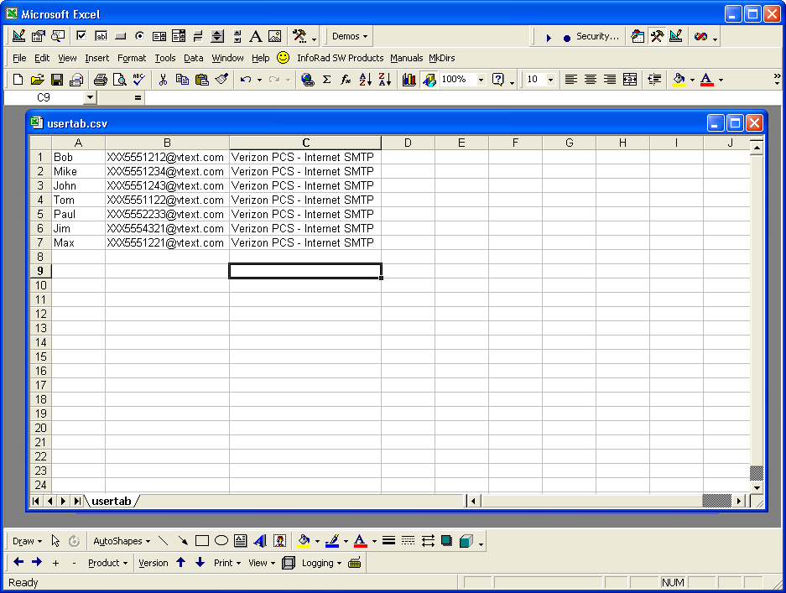

Make sure to change the Save as Type to CSV (MS-DOS) (*.csv) at the bottom. This will make it so that it is Comma-Delimited.

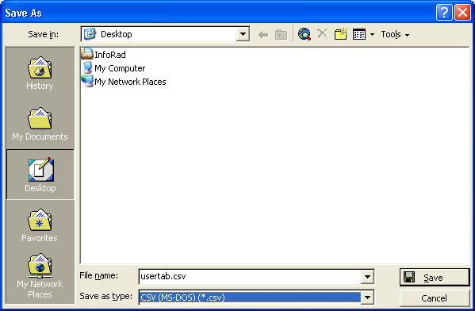

You can right click on your usertab.csv file and choose to Open With Notepad. The contents of the file should look similar to:

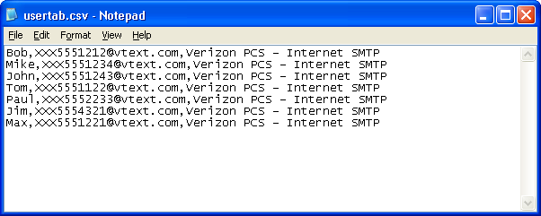

You can now run the txt2irt.exe on the usertab.csv file (on the command line).

