The pictures here will provide you with a visual of adding InfoRad’s Winpage.exe to the exception list of McAfee Enterprise 8.0.0’s VirusScan. Therefore, Winpage.exe will not be seen as a Worm or other virus.

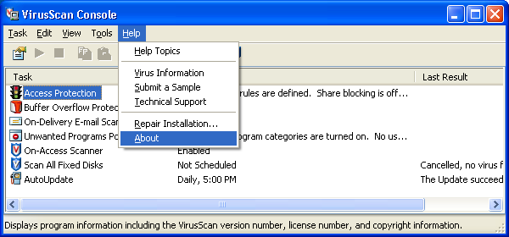

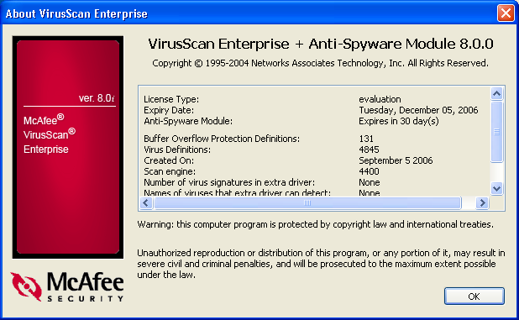

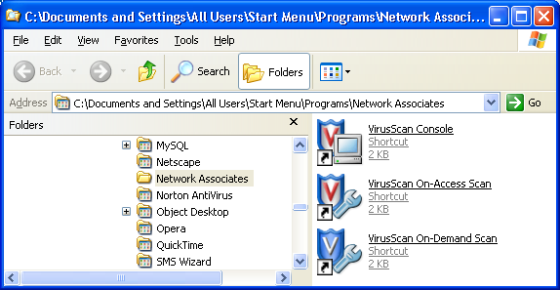
Launch the VirusScan Console. Normally, it’s found under Start, Program Files (or All Programs), Network Associates, VirusScan Console

Right Click on Access Protection and select Properties

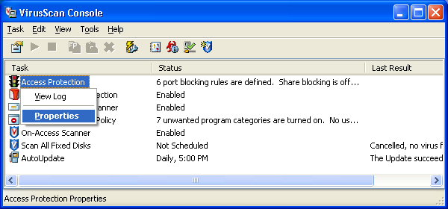

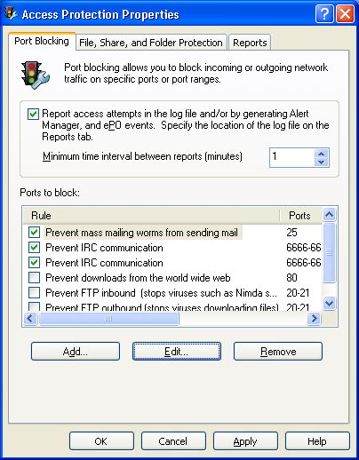
Click (to check if not already checked) to select the option to Prevent mass mailing worms from sending mail. Next, Click the Edit button.

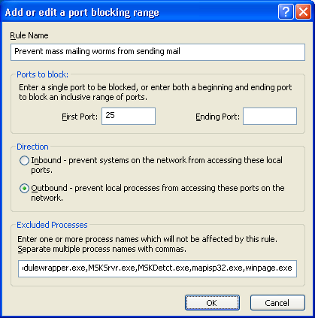
At the end of the Excluded Processes list,
Enter a comma followed by winpage.exe

…. , winpage.exe

Once everything is entered correctly, Click OK for all windows and send a test page.
In result, error 6101 should go away and your message(s) should be received at the device (pager or cell phone or email address).

