1. Starting the Installation - InfoRad Wireless Office/Pro/eText 10.0.0 Installation

Prev Step: None | Next Step: License Agreement
- Click Start on the Windows Desktop
THE BROWSE BUTTON ALL0WS YOU TO OPEN OR RUN A PROGRAM (SUCH AS INFORAD WIRELESS MESSAGING SOFTWARE), OR OPEN A FOLDER OR FILE (SUCH AS THE INFORAD WIRELESS FOLDER OR AN INFORAD LOG FILE).
- Click to Select Run. Type D:\SETUP in the "Open:" text box
- Click OK
- Follow the Steps shown below for Installation and Program Setup
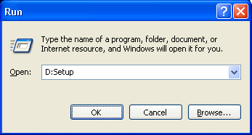

2. License Agreement - InfoRad Wireless Office/Pro/eText 10.0.0 Installation

Prev Step: Installation | Next Step: Welcome
Return to top of page
If you agree to the terms of the License Agreement, then click "I Agree" to continue with the installation process.
YOU AGREE TO THE TERMS WRITTEN IN THE LICENSE AGREEEMENT
Bottom of Form
Top of Form
YOU DISAGREE TO THE TERMS WRITTEN IN THE LICENSE AGREEEMENT
Otherwise, click "I Don't Agree" to abort the installation.
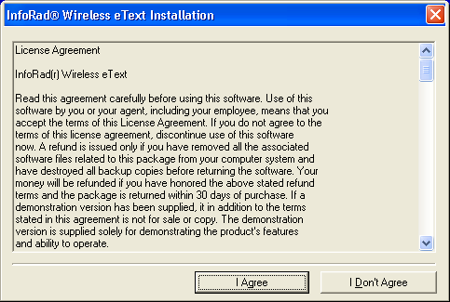

3. Welcome - InfoRad Wireless Office/Pro/eText 10.0.0 Installation

Prev Step: License Agreement | Next Step: Select Destination Directory
Return to top of page
Click the "Next>" button to continue with the Installation. Click Cancel to abort the installation.
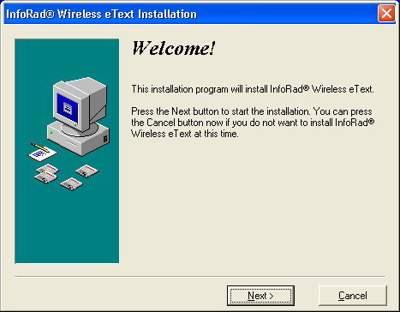

4. Select Destination Directory - InfoRad Wireless Office/Pro/eText 10.0.0 Installation

Prev Step: Welcome | Next Step: All Users
Return to top of page
Click on the "Browse" button to change the default destination directory. Once you've decided the Destination Directory to install the InfoRad Wireless software, click the "Next>" button to continue with the Installation.
THE BROWSE BUTTON ALL0WS YOU TO BROWSE FOR AN ALTERNATE DIRECTORY IN WHICH TO INSTALL THE INFORAD WIRELESS MESSAGING SOFTWARE.
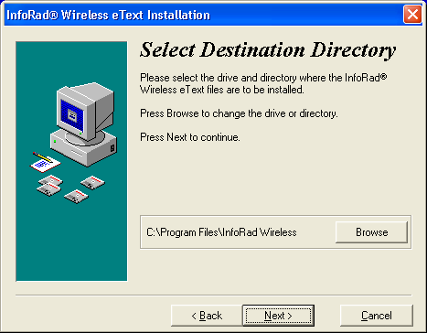

5. All Users - InfoRad Wireless Office/Pro/eText 10.0.0 Installation

Prev Step: Select Destination Directory | Next Step: ShortCut Setup
Return to top of page
You are given the option to install the software for the "Current User only" or for "All Users of this computer".
You have chosen to INSTALL THE SOFTWARE FOR THE CURRENT USER ONLY. OTHER USERS WILL NOT HAVE ACCESS TO USE THE INFORAD WIRELESS SOFTWARE.
Bottom of Form
Top of Form
You have chosen to INSTALL THE SOFTWARE FOR ALL USERS OF THIS COMPUTER.
Click the "Next>" button to continue with the Installation or click "<Back" to change previous options.
Click here if this is not the screen you see!
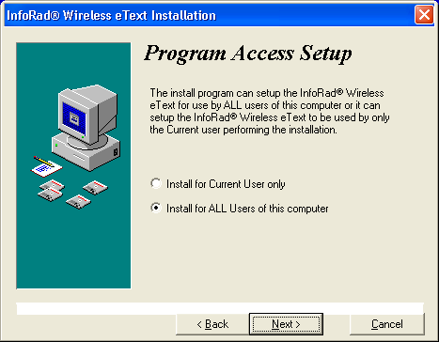

6. Shortcut Setup - InfoRad Wireless Office/Pro/eText 10.0.0 Installation

Prev Step: All Users | Next Step: Ready To Install
Return to top of page
Decide whether or not to place a shortcut on your Windows desktop. Click the "Next>" button to continue with the Installation or click "<Back" to change previous options.
You have chosen to PLACE AN ICON ON THE DESKTOP.
Bottom of Form
Top of Form
You have chosen DO NOT PLACE AN ICON ON THE DESKTOP.
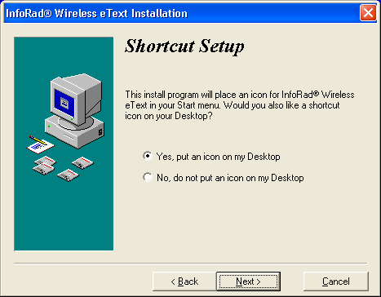

7. Ready to Install - InfoRad Wireless Office/Pro/eText 10.0.0 Installation

Prev Step: ShortCut Setup | Next Step: Installing
Return to top of page
Last Call before Install! InfoRad will now install the software using the options that you've previously chosen. Click the "Next>" button to continue with the Installation or click "<Back" to change previous options.
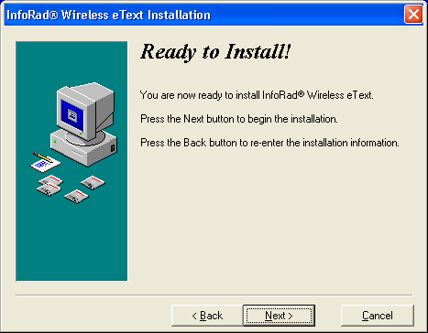

8. Installing - InfoRad Wireless Office/Pro/eText 10.0.0 Installation

Prev Step: Ready To Install | Next Step: Ready For Program Setup  ONCE THE STATUS BAR REACHES 100%, THE INFORAD SOFTWARE IS COMPLETELY INSTALLED. AT THAT POINT, IT WOULD BE SAFE TO CANCEL THE PROGRAM SETUP (BECAUSE YOU CAN SETUP THE SOFTWARE FROM THE SOFTWARE ITSELF). OTHERWISE, BEYOND THIS POINT, THE SOFTWARE WILL GUIDE YOU THROUGH SETTING UP THE MODEM OR NETWORK CONNECTION
Return to top of page
The only option provided during the Installing process is the option to Cancel. Of course, the objective here would be to complete the Installation 100% as shown.
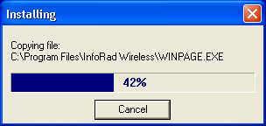
Once the installation is complete, the InfoRad Wireless Office/Pro/eText Setup program will guide you through setting up the software to send messages via a Modem or Network (Internet). If you're installing an Upgrade and you have already setup the previously installed software, then you can Cancel the Program Setup and abort the Installation. Otherwise, you may wish to continue with the Program Setup Wizard.
Installation is Complete.

1. Ready for Program Setup - InfoRad Wireless Office/Pro/eText 10.0.0 Installation

Prev Step: Installing |  | Next Step: via Modem
Return to top of page | or | Next Step: via Network  DON'T WORRY, EITHER WAY, YOU ARE NOT BOUND TO ONLY SENDING MESSAGES VIA A DIALUP MODEM OR VIA THE INTERNET. YOU CAN HAVE BOTH. THE INSTALLATION ONLY ASKS FOR INITIAL PROGRAM SETUP.
How Will You Initially Be Sending Messages? Don't worry, InfoRad will not hold you to it.  You can send messages via a MODEM, a NETWORK (or INTERNET) CONNECTION, or BOTH!  Choose to send messages "via MODEM" or "via NETWORK" as shown below. Note that you are not bound to this method of sending messages. You may change these options at any time in the software under Edit, Messaging Services. Click the "Next >" button to continue with Program Setup.  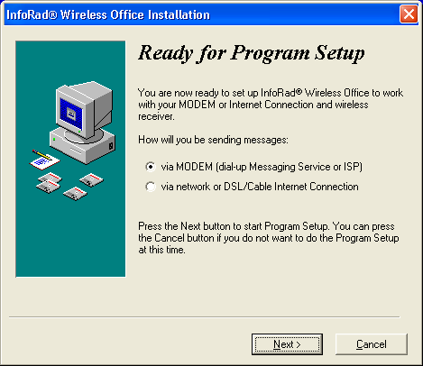 |  |  | Top of Form  KEEP IN MIND THAT THE MESSAGE IS SENT ACCORDING TO THE MESSAGING SERVICE CHOSEN FOR A PARTICULAR RECEIVER. THEREFORE, IF YOU HAVE A MESSAGING SERVICE SELECTED FOR A PARTICULAR RECEIVER THAT CONTAINS A PHONE NUMBER, YOU WILL NEED A DIALUP MODEM TO DIAL THE PHONE NUMBER. OTHERWISE, IF THE MESSAGING SERVICE (SELECTED FOR THAT PARTICULAR RECEIVER) HAS AN INTERNET ADDRESS, YOU WILL NEED AN INTERNET CONNECTION TO SEND THE MESSAGE.  TO USE BOTH, CREATE A RECEIVER CALLED "JOE INTERNET" THAT USES AN INTERNET MESSAGING SERVICE AND CREATE A RECEIVER "JOE DIALUP" THAT USES A DIALUP MESSAGING SERVICE.  Bottom of Form

2. via Modem - InfoRad Wireless Office/Pro/eText 10.0.0 Installation

Prev Step: Ready For Program Setup | Next Step: Communications Setup
Return to top of page
You've chosen to setup the InfoRad software to send via a Modem. Again, you are not bound to only using your modem. Here you can check your computer's dialing properties for the modem. Check to see that the information you have there matches (i.e., does the Area Code match your location, do the numbers for Accessing an Outside Line match?). Click the "Next >" button to continue with Program Setup.
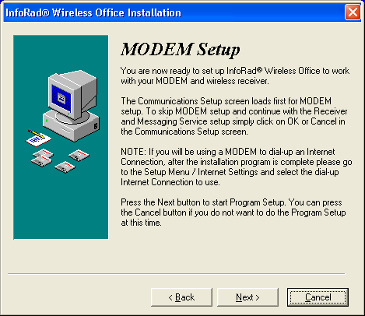

3. Communications Setup - InfoRad Wireless Office/Pro/eText 10.0.0 Installation

Prev Step: via Modem |  | Next Step: Dialing Tab
Return to top of page | or | Next Step: Add Wireless Receiver, Step 1
By default, InfoRad Wireless software is set to "Use the system's modem configuration". You can also create an initialization string by clicking on "Override the system's modem configuration." and clicking the Create button. Once the software is done testing the modem for extended commands, an Initialization string will appear in the text box as shown. Click the "OK" button to continue with Program Setup.  You can also configure the Modem's dialing properties by clicking on the Dialing Tab  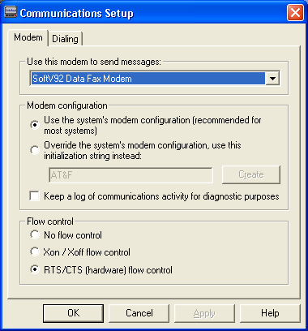 |  |  | MODEM CONFIGURATION:  Top of Form  USING THE SYSTEM'S (WINDOWS) MODEM CONFIGURATION. WINDOWS WILL INITIALIZE YOUR MODEM AND MAKE THE CONNECTION. MAKE SURE TO SETUP YOUR MODEM CONFIGURATION ACCORDING TO OUR WEBSITE INSTRUCTIONS:  Bottom of Form  Top of Form  OVERRIDE THE SYSTEM'S (WINDOWS) MODEM CONFIGURATION: WHEN YOU SELECT THIS OPTION AND CLICK ON THE "CREATE" BUTTON, INFORAD WILL COMMUNICATE WITH THE MODEM AND CREATE AN INIT STRING FOR THE MODEM TO USE.  Bottom of Form  Top of Form  THE INFORAD SOFTWARE WILL LOG ALL MESSAGES SENT VIA THE MODEM. THESE LOG FILES WILL BE CALLED CMXXYYYY WHERE X = THE DAY OF THE MONTH AND Y = THE TIME. THE LOG FILES CAN BE FOUND IN THE WORKING DIRECTORY OF INFORAD WIRELESS (BY DEFAULT, C:\PROGRAM FILES\INFORAD WIRELESS)  Bottom of Form

1. Wireless Receiver Wizard - InfoRad Wireless Office/Pro/eText 10.0.0 Installation

Prev Step: Communications Setup | Next Step: Add Wireless Receiver,Step2
Return to top of page
The Wireless Receiver Setup Wizard will walk you through the steps of setting up a Receiver. Click the "Next >" button to continue with Program Setup. Click "Exit" to exit the Wizard (You can setup a Receiver at any time).
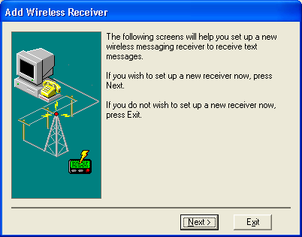

2. Wireless Receiver Wizard - InfoRad Wireless Office/Pro/eText 10.0.0 Installation

Prev Step: Add Wireless Receiver,Step1 | Next Step: Add Wireless Receiver,Step3
Return to top of page
The Wireless Receiver Setup Wizard prompts you to enter a Name or meaningful word for the pager, cell phone, or other device to which you will be sending messages. There are no limitations here except length. The length cannot exceed 32 characters.
Click the "Next >" button to continue with Program Setup or click "<Back" to change previous options.. Click "Exit" to exit the Wizard (You can setup a Receiver at any time).
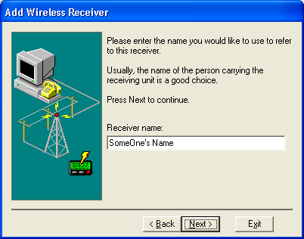

3. Wireless Receiver Wizard - InfoRad Wireless Office/Pro/eText 10.0.0 Installation

Prev Step: Add Wireless Receiver,Step2 | Next Step: Add Wireless Receiver,Step4
Return to top of page
The Wireless Receiver Setup Wizard prompts you to enter the Receiver's ID number. Normally, when connecting to 800 number paging services or sending via the Internet, the Receiver's ID number (or PIN = Pager Identification Number) is the 10-digit-phone-number of the pager or cell phone, without dashes or spaces. Otherwise, the Receiver's ID number may be the 7-digit-phone-number, again without dashes or spaces.
If you're unsure what the Receiver's ID number (or PIN) should be, contact your local paging service representative or cellular carrier for this information. You may also refer to the List of Messaging Services located on the InfoRad website for many of the required PINs.
Click the "Next >" button to continue with Program Setup or click "<Back" to change previous options.. Click "Exit" to exit the Wizard (You can setup a Receiver at any time).
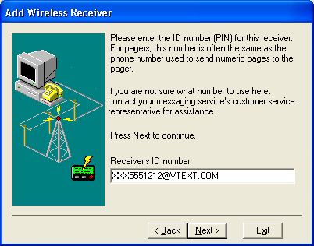

4. Wireless Receiver Wizard - InfoRad Wireless Office/Pro/eText 10.0.0 Installation

Prev Step: Add Wireless Receiver,Step3 | Next Step: Add Wireless Receiver,Step5
Return to top of page
The Wireless Receiver Setup Wizard prompts you to enter the Receiver's ID number. Normally, when connecting to 800 number paging services or sending via the Internet, the Receiver's ID number (or PIN = Pager Identification Number) is the 10-digit-phone-number of the pager or cell phone, without dashes or spaces. Otherwise, the Receiver's ID number may be the 7-digit-phone-number, again without dashes or spaces.
If you're unsure what the Receiver's ID number (or PIN) should be, contact your local paging service representative or cellular carrier for this information. You may also refer to the List of Messaging Services located on the InfoRad website for many of the required PINs.
Click the "Next >" button to continue with Program Setup or click "<Back" to change previous options.. Click "Exit" to exit the Wizard (You can setup a Receiver at any time).
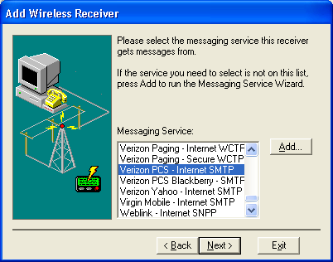

5. Wireless Receiver Wizard - InfoRad Wireless Office/Pro/eText 10.0.0 Installation

Prev Step: Add Wireless Receiver,Step4 | Next Step: Add Messaging Service,Step1
Return to top of page
The Wireless Receiver Setup Wizard prompts you to enter the Receiver's ID number. Normally, when connecting to 800 number paging services or sending via the Internet, the Receiver's ID number (or PIN = Pager Identification Number) is the 10-digit-phone-number of the pager or cell phone, without dashes or spaces. Otherwise, the Receiver's ID number may be the 7-digit-phone-number, again without dashes or spaces.
If you're unsure what the Receiver's ID number (or PIN) should be, contact your local paging service representative or cellular carrier for this information. You may also refer to the List of Messaging Services located on the InfoRad website for many of the required PINs.
Click the "Next >" button to continue with Program Setup or click "<Back" to change previous options.. Click "Exit" to exit the Wizard (You can setup a Receiver at any time).
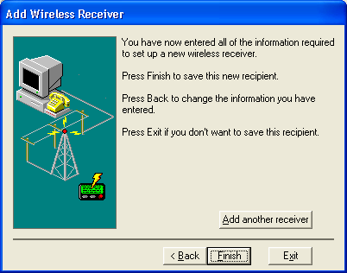

1. Messaging Service Wizard - InfoRad Wireless Office/Pro/eText 10.0.0 Installation

Prev Step: Add Wireless Receiver,Step5 | Next Step: Add Messaging Service,Step2
Return to top of page
The Messaging Service Setup Wizard will walk you through the steps of setting up a New Messaging Service. Click the "Next >" button to continue with Program Setup. Click "Exit" to exit the Wizard (You can setup a Receiver at any time).
You may also refer to the default List of Messaging Services located on the InfoRad website.
Click the "Next >" button to continue with Program Setup or click "<Back" to change previous options.. Click "Exit" to exit the Wizard (You can setup a Receiver at any time).
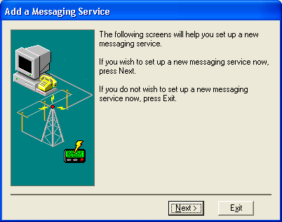

2. Messaging Service Wizard - InfoRad Wireless Office/Pro/eText 10.0.0 Installation

Prev Step: Add Messaging Service,Step1 | Next Step: Add Messaging Service,Step3
Return to top of page
The Messaging Service Setup Wizard will walk you through the steps of setting up a New Messaging Service. Click the "Next >" button to continue with Program Setup. Click "Exit" to exit the Wizard (You can setup a Receiver at any time).
You may also refer to the default List of Messaging Services located on the InfoRad website.
Click the "Next >" button to continue with Program Setup or click "<Back" to change previous options.. Click "Exit" to exit the Wizard (You can setup a Receiver at any time).
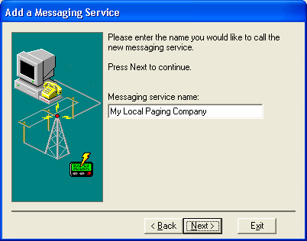

3. Messaging Service Wizard - InfoRad Wireless Office/Pro/eText 10.0.0 Installation

Prev Step: Add Messaging Service,Step2 | Next Step: Add Messaging Service,Step4
Return to top of page
The Messaging Service Setup Wizard will walk you through the steps of setting up a New Messaging Service. Click the "Next >" button to continue with Program Setup. Click "Exit" to exit the Wizard (You can setup a Receiver at any time).
You may also refer to the default List of Messaging Services located on the InfoRad website.
Click the "Next >" button to continue with Program Setup or click "<Back" to change previous options.. Click "Exit" to exit the Wizard (You can setup a Receiver at any time).
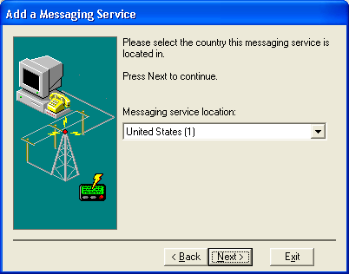

4. Messaging Service Wizard - InfoRad Wireless Office/Pro/eText 10.0.0 Installation

Prev Step: Add Messaging Service,Step3 | Next Step: Add Messaging Service,Step5
Return to top of page
The Messaging Service Setup Wizard will walk you through the steps of setting up a New Messaging Service. Click the "Next >" button to continue with Program Setup. Click "Exit" to exit the Wizard (You can setup a Receiver at any time).
You may also refer to the default List of Messaging Services located on the InfoRad website.
Click the "Next >" button to continue with Program Setup or click "<Back" to change previous options.. Click "Exit" to exit the Wizard (You can setup a Receiver at any time).
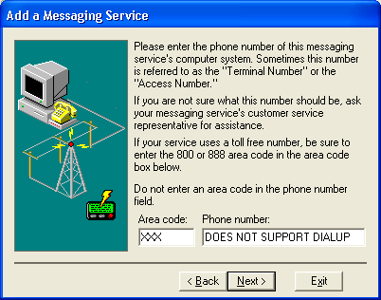

5. Messaging Service Wizard - InfoRad Wireless Office/Pro/eText 10.0.0 Installation

Prev Step: Add Messaging Service,Step4 | Next Step: Add Messaging Service,Step6
Return to top of page
The Messaging Service Setup Wizard will walk you through the steps of setting up a New Messaging Service. Click the "Next >" button to continue with Program Setup. Click "Exit" to exit the Wizard (You can setup a Receiver at any time).
You may also refer to the default List of Messaging Services located on the InfoRad website.
Click the "Next >" button to continue with Program Setup or click "<Back" to change previous options. Click "Exit" to exit the Wizard (You can setup a Receiver at any time).
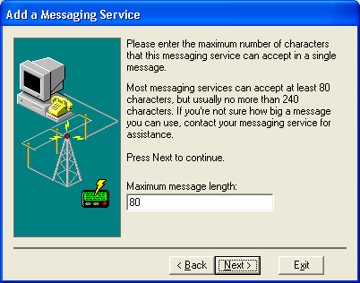

6. Messaging Service Wizard - InfoRad Wireless Office/Pro/eText 10.0.0 Installation

Prev Step: Add Messaging Service,Step5 | Next Step: Registration Information
Return to top of page
The Messaging Service Setup Wizard will walk you through the steps of setting up another New Messaging Service. Click the "Next >" button to continue with Program Setup or click "<Back" to change previous options.. Click "Exit" to exit the Wizard (You can setup a Receiver at any time).

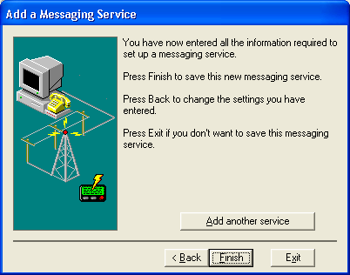

4. Dialing Properties - InfoRad Wireless Office/Pro/eText 10.0.0 Installation

Prev Step: Communications Setup | Next Step: Phone and Modem Options
Return to top of page
When setting up your InfoRad Wireless Software, be sure to check your Dialing Properties in Microsoft Windows 95/98/NT/XP. Click Start, under Settings click Control Panel, and in Control Panel, double click on Modems. This will bring up your Modems Properties. Inside Modems Properties click on Dialing Properties button.
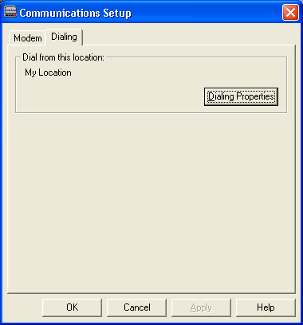

5. Phone And Modem Options - InfoRad Wireless Office/Pro/eText 10.0.0 Installation

Prev Step: Dialing Properties | Next Step: Edit Location
Return to top of page
Here you can check your computer's dialing properties for it's modems. Check to see that the information you have there matches (i.e., does the Area Code match your location, do the numbers for Accessing an Outside Line match?).
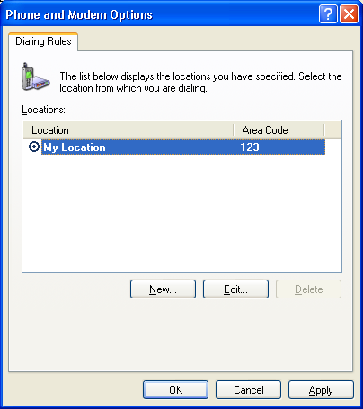

6. Edit Location - InfoRad Wireless Office/Pro/eText 10.0.0 Installation

Prev Step: Phone And Modem | Next Step: Area Code Rules
Return to top of page
Here you can check your computer's dialing properties for it's modems. Check to see that the information you have there matches (i.e., does the Area Code match your location, do the numbers for Accessing an Outside Line match?).
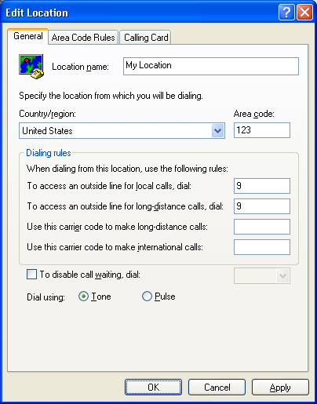

7. Area Code Rules - InfoRad Wireless Office/Pro/eText 10.0.0 Installation

Prev Step: Edit Location | Next Step: Edit Area Code Rule
Return to top of page
Here you can check your computer's dialing properties for it's modems. Check to see that the information you have there matches (i.e., does the Area Code match your location, do the numbers for Accessing an Outside Line match?).
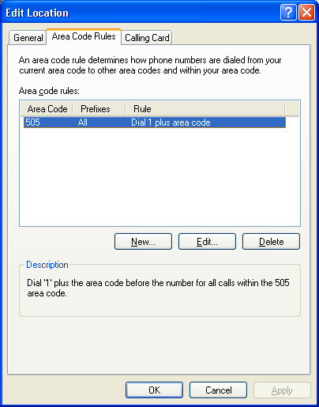

8. Edit Area Code Rule - InfoRad Wireless Office/Pro/eText 10.0.0 Installation

Prev Step: Area Code Rules | Next Step: Registration Information
Return to top of page
Here you can check your computer's dialing properties for it's modems. Check to see that the information you have there matches (i.e., does the Area Code match your location, do the numbers for Accessing an Outside Line match?).
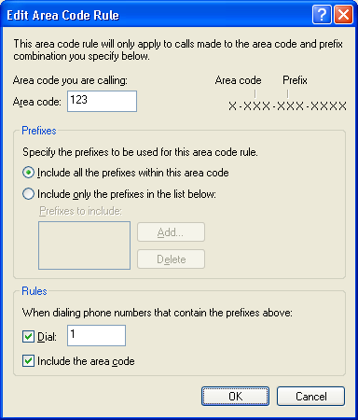

9. Registration Information - InfoRad Wireless Office/Pro/eText 10.0.0 Installation

Prev Step: via Network | Next Step: Installation Completed
Prev Step: via Modem | Return to top of page
The Registration Wizard will not let you exit until you fill out the form. However, it does give you the option to Register Now or Register Later.
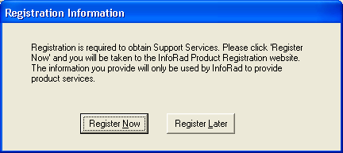

10. Installation Completed - InfoRad Wireless Office/Pro/eText 10.0.0 Installation

Prev Step: Registration Information | Next Step: None
Return to top of page
Thank You For Choosing InfoRad Wireless! Click Finish to complete the Installation.
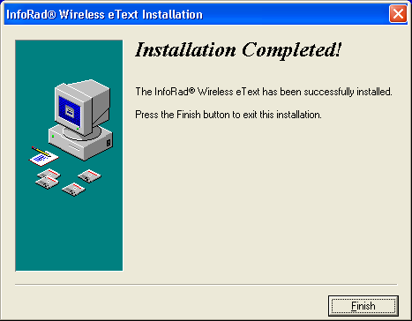

I. Aborting the Installation - InfoRad Wireless Office/Pro/eText 10.0.0 Installation

Prev Step: NA | Next Step: None
Return to top of page
Click Yes to abort the installation or click No to continue with the installation.
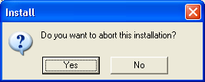

II. Exit Without Saving - InfoRad Wireless Office/Pro/eText 10.0.0 Installation

Prev Step: NA | Next Step: None
Return to top of page
Click Yes to Exit without saving or click No to continue with the Setup.
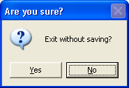

Copyright © 2000 - 2003 InfoRad, Inc.
All Rights Reserved
Makers of AlphaPage® Wireless Messaging Products since 1985.
Bottom of Form

