Installation –

Run the Setup.exe from your CD-ROM or zip/exe file from the web download on the new Server PC. The Setup.exe/Download file will install all files in the InfoRad\Wireless Enterprise and Wireless Enterprise Settings folders (including the "APC_CLI.exe" and the Client Setup.exe).

Run the Server application and transfer database files –

Run the Server application from the shortcut that was placed on the desktop. At this point, you can load the Program Files from the older application. Follow the steps below:

From the old Server:
- Click File
- Select Save Program Files (or Save Database Files)
- Browse to a shared network folder, burnable CD-ROM, or a familiar location to which you can save…
- Click Save

At this time, you may also want to copy any settings from this Server application under the Setup menu. If using dialup Messaging Services, click Setup and select Communications (It’s not necessary to copy over settings from under Dialing tab at this point). If Internet Messaging Services only, click Setup and select Internet Settings (Make sure to check Telnet Proxy and ReplyTo Address tabs also). If both, then of course, copy settings from both.

Also copy settings from Setup, Preferences and Setup, ASCII File Processing Setup, but EXCLUDE MESSAGES PATH, do not copy.

If desired, you may also copy Previously Sent Messages, Predefined Messages, and Scheduled Messages from the Wireless Enterprise folder. However, you will need to copy them over manually. Copy them to the new Wireless Enterprise folder.

Predefined Messages = PREDEF.IRT
Previously Sent Messages = prvmsg.irt
Scheduled Messages = SCHEDMSG.IRT

From the new Server:
- Click File
- Select Load Program Files
- Browse to the location from which the older database / program files were saved from the step above…
- You may have to select Legacy Database Files if the database files consist of Usertab.irt, Grouptab.irt, and Termtab.irt
- Click Open. Note that it does not matter if you select one or not, the software will load all database files in regardless.

If the software prompts you with “if loading from an older version of Office or eText” then make sure to choose the correct option.

Once the database / program files are loaded successfully into the new Server application, send a test page to one of the Receivers for testing.

Share the Wireless Enterprise folder –

Windows may provide only read permissions to the InfoRad folder upon installation, so make sure that you share out the InfoRad\Wireless Enterprise folder to the network.

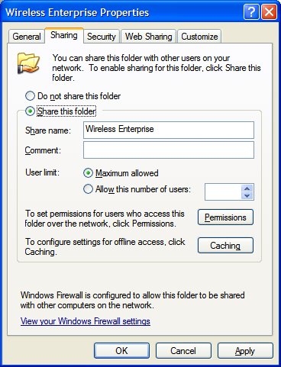

It is common practice to allow Full Control permissions to the Everyone group. Later, you can grant or deny permissions from the Security tab.

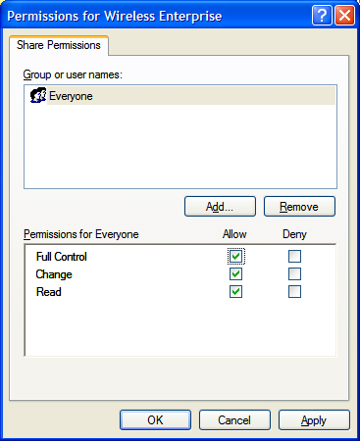

We recommend that you provide full control permissions to the necessary users/groups (including Domain Users if necessary) who are going to use the Enterprise Client application.

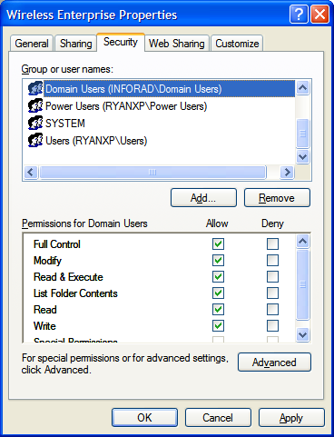
Here, we add Domain Users, which we reside on the InfoRad Domain, and allow the Domain Users Full Control permissions. This will get you up and running.

If needed, there are ways to lock down the permissions to prevent tampering of files.

If desired, refer to the Enterprise User's Manual for a guide to lockdown (http://www.inforad.com/usermanuals.html).

Make sure that you keep the Server application up and running, at least minimized, to send out text messages for the Clients installed out in the network (as directed below). If the Enterprise software is installed on a server PC that needs to be logged off, then you’ll need to switch your software to the InfoRad Enterprise SV that comes with a Service that can work in the background while the server PC is logged off. Refer to sales@inforad.com for more information.

Installing and Testing New Clients and Removing the Old –

From a workstation without a Client application, browse through the network to the Server's shared Wireless Enterprise folder. We recommend using the UNC path. For example, click Start, Run, enter \\ServerName and press enter, then locate the Wireless Enterprise folder. Run the Client Setup.exe to install a Client on that workstation. We also recommend installing for All Users. If this Client works successfully, then you can move on to install the remaining Clients.

To upgrade older Clients, first run the Uninstall for the old Client, then repeat the process for installing the new Client.

Note that If the Client application shows "Server Unavailable" in red, then it may be either the Server application is not running on the "Server PC", the Client's Message Directory is no longer pointed to the correct location (or message directory found in the Client under Setup, Preferences), or the Client does not have the necessary read/write privileges to the message directory shared from the Server.

If the Client error terminates with some 5XXX error, refer to http://www.inforad.com/techsupport/help%20center/index.php3?searchtxt=APC%20Error for resolution.

Removing the Old Server application –

Once all Clients are successfully sending their messages to the new Server, you can then run the Uninstall for the old Server application.

Again, give us a call or send us an email if you get stuck or have problems.

(800) 228-8998

techsupport@inforad.com

