Installation –

Run the Setup.exe found on your CD-ROM (or zip/exe file from the web download, enterprise_d for demos). The Setup.exe/Download file will install all files in the InfoRad\Wireless Enterprise and Wireless Enterprise Settings folders – Trial will be at the end of the folder name for demos - (including the "APC_CLI.exe" and the Client Setup.exe).

Share the Wireless Enterprise folder –

Windows may provide only read permissions to the InfoRad folder upon installation, so make sure that you share out the InfoRad\Wireless Enterprise (Trial) folder to the network.

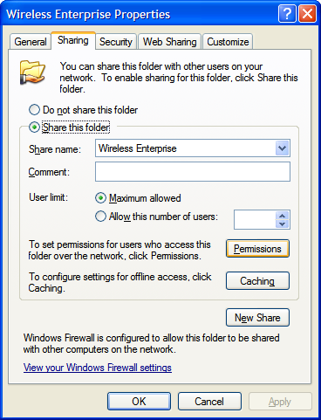

We recommend that you provide full control permissions to the necessary users/groups (including Domain Users if necessary) who are going to use the Enterprise Client application. If desired, refer to the Enterprise User's Manual for a guide to lockdown (http://www.inforad.com/usermanuals.html).

Make sure that you keep the Server application up and running, at least minimized, to send out text messages for the Clients installed out in the network (as directed below). If the Enterprise software is installed on a server PC that needs to be logged off, then you’ll need to switch your software to the InfoRad Enterprise SV that comes with a Service that can work in the background while the server PC is logged off (AlphaCare customers, refer to sales@inforad.com for more information).

Installing and Testing New Clients –

From a workstation, browse through the network to the Server's shared Wireless Enterprise (Trial) folder. We recommend using the UNC path. For example, in Windows, click Start and select Run, enter \\ServerName and press enter…

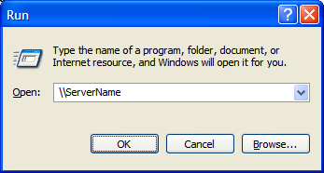

Then locate the Wireless Enterprise (Trial) folder. Run the Client Setup.exe to install a Client on that workstation. We also recommend installing for All Users.

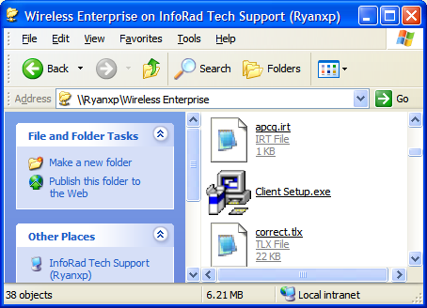

Run one of the Client applications to test page making sure that the Clients are sending pages correctly. If the Client application shows "Server Unavailable" in red, then it may be either the Server application is not running on the "Server PC", the Client's Message Directory is no longer pointed to the correct location (or message directory found in the Client under Setup, Preferences), or the Client does not have the necessary read/write privileges to the message directory shared from the Server.

If the Client error terminates with some 5XXX error, refer to http://www.inforad.com/techsupport/Errors/Errors%202007.htm#APCErrors for resolution.

I hope this is clear for you. Please do not hesitate to contact us via phone or email regarding any further questions or concerns.

Feel free to contact us with your technical questions at (216) 531-1369 or (800) 228-8998 ext. 2 for Tech Support. Our Normal business hours are from 8:30AM until 5:30PM Eastern Time.
Thank You,
Creighton Ryan
InfoRad Tech Support
mailto:techsupport@inforad.com
http://www.inforad.com/techsupport

