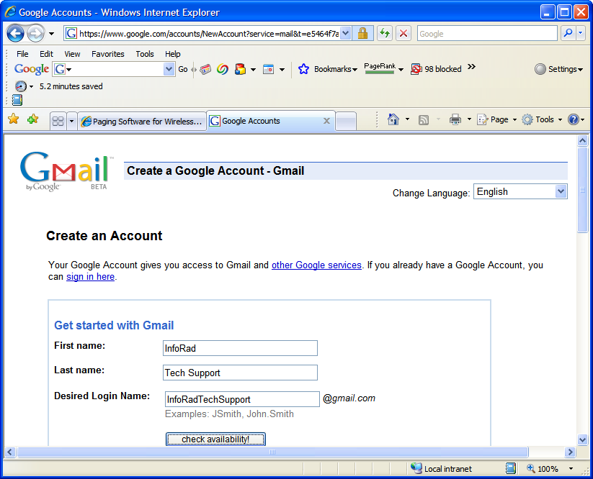
If you do not already have a GMail account, then the first thing you will need to do is create your free GMail Account with Google. Refer to the following URL:

https://www.google.com/accounts/NewAccount?service=mail

Next Step

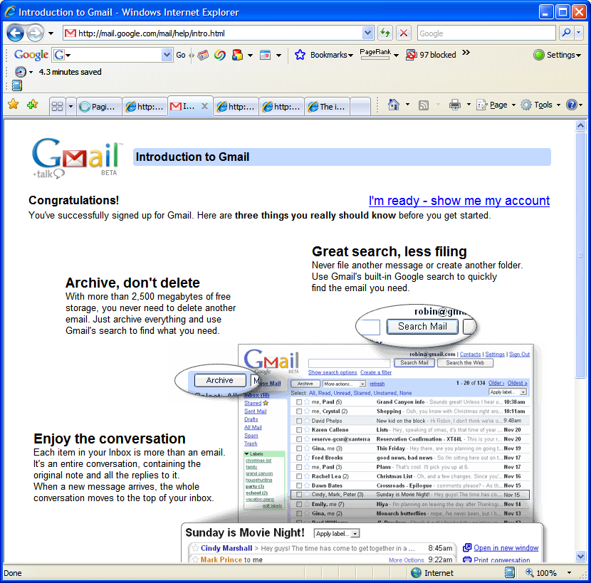
Once you have your GMail account created and activated (make sure to follow all the steps Google provides for you), then you can log into your account over a secure connection using the following link:

https://mail.google.com/mail/

NOTE: You do not need to be logged into your account with your Internet browser in order to send text messages using your InfoRad software. However, you will be able to see the messages show up in your Sent folder that were sent using the InfoRad software. You’ll see what I’m talking about below.

Next Step

 Using Google to send text messages via Internet mail (SMTP)
This document shows you how to setup the InfoRad software to send text messages using Google’s email server to various cell phones via Internet email (SMTP).

Begin

Step 1. Click Edit and select Receivers |  | Next Step
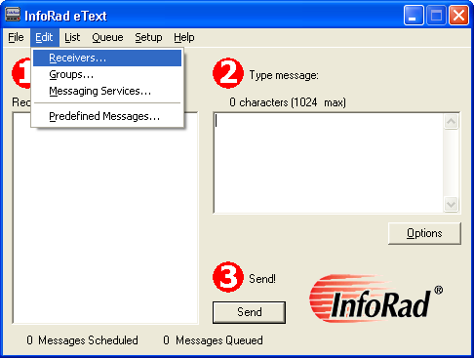
Click Edit and select Receivers

 |  | Top

Step 2. Click the New button to add a new Receiver | Prev Step | Next Step
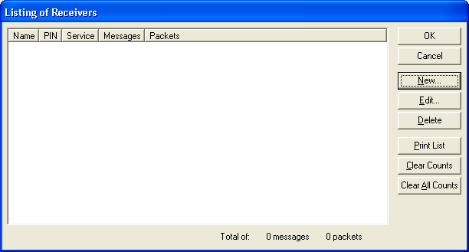
Click the New button to add a new Receiver

 |  | Top

Step 3. Enter the Receiver information as shown  First, Enter whatever you’d like for the “Name of the person carrying this receiver” and enter the appropriate Receiver ID.  For example, use XXX5551212@vtext.com for Verizon cell phones, XXX5551212@message.alltel.com for Alltel cell phones, or enter techsupport@inforad.com to send us an email when you need help!  If needed, refer to our website for many other cell phone and pager email address formats: Click here | Prev Step | Next Step
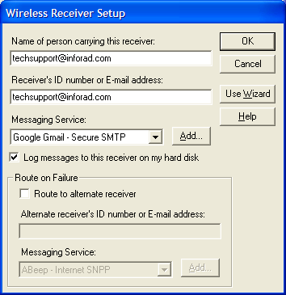
Next, Click to select Google Email – Secure SMTP.
Finally, Click the OK button when finished.
 |  | Top

Step 4. Click OK for the List of Receivers window | Prev Step | Next Step
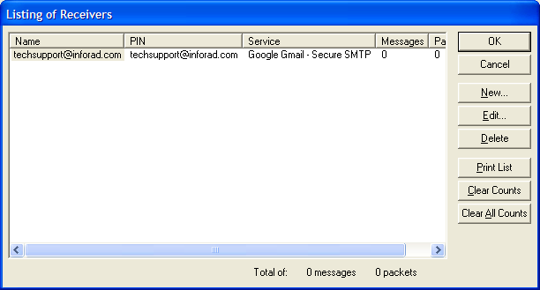
Click the OK button to accept the newly added Receiver.

 |  | Top

Step 5. Edit Google’s Messaging Service | Prev Step | Next Step
Click Edit and select Messaging Services
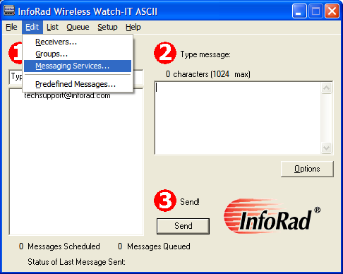
 |  | Top

Step 6. Edit Google’s Messaging Service | Prev Step | Next Step
Scroll to Google Gmail – Secure SMTP and Click the Edit button
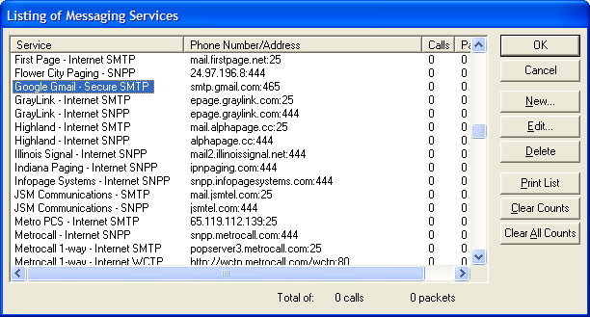

 |  | Top

Step 7. Edit Google’s Messaging Service | Prev Step | Next Step
Enter the information as shown:
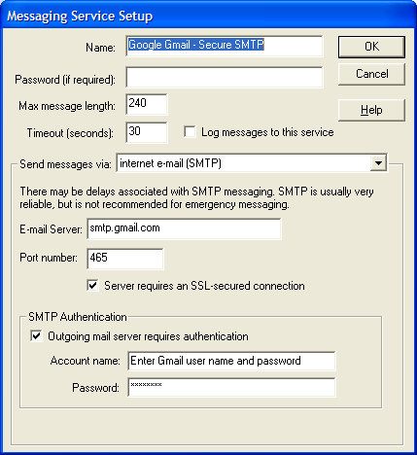
D. Enter Google Gmail – Secure SMTP for the Name of the Messaging Service

Enter 240 for the Max message length

For “Send messages via” click to select “Internet e-mail (SMTP)”

Enter smtp.gmail.com for the “E-mail Server”

Leave the port number at 465 and check Server requires an SSL-secured connection

Check SMTP Authentication and enter your Gmail User Name and Password so that InfoRad can send it to Google’s GMail server.

Verify all information and click the OK button.

Top

Step 8. Click OK for the List of Messaging Services window | Prev Step | Next Step
Click the OK button for the Listing of Messaging Services window to accept the new Messaging Service information.

 |  | Top

Step 9. Click Setup and Select Internet Settings | Prev Step | Next Step
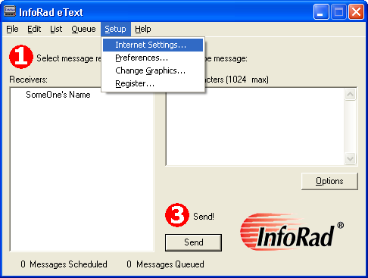

 |  | Top

Step 10. Click on the ReplyTO Address tab and enter your email address. Click OK. | Prev Step | Next Step
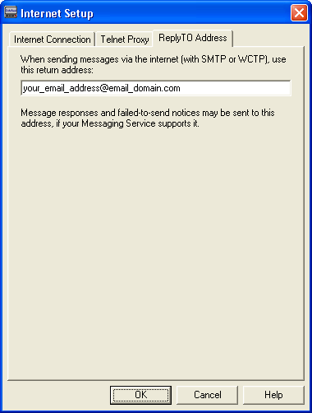

 |  | Top

Step 11. Send the Receiver a test page | Prev Step | Next Step
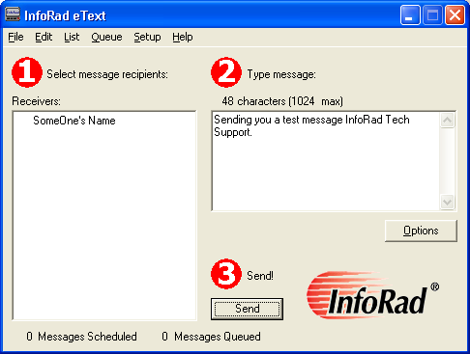
3. Click the Send button or press Enter on the keyboard
1. Click on the Receiver
2. Enter a Message to send

 |  | Top

Step 12. Any errors? Yes / No | Prev Step
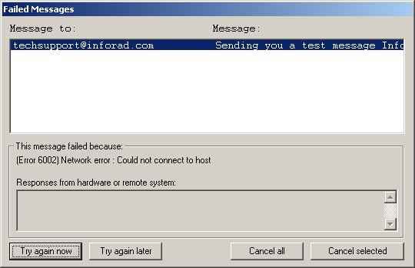
Did you receive any failed message errors? Yes / No

 |  | Top

Step 13. Helpful Tips? | Prev Step | Next Step
- Check your email: In Step 7, you entered your email address. You can check your email to see if there were any emails returned to you. For instance, if you entered an incorrect email address (XXX5551212@cellular_company.com was not entered correctly), then sometimes the email server will respond back to your email to let you know.

- Make sure the message got to the phone.

 |  | Top

Don’t forget to check your Sent Folder | Top

