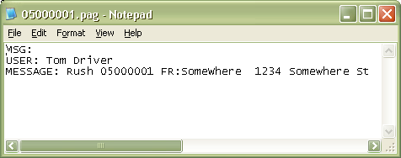
This is an example of a file created by CST (Database Services) software. One thing to note is the USER: name “Tom Driver”. This user must match one of the listed Receivers as it shows in the InfoRad software.
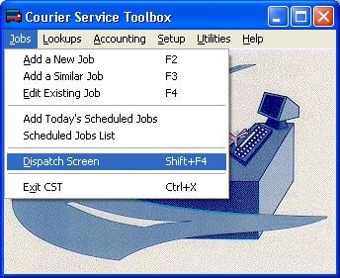

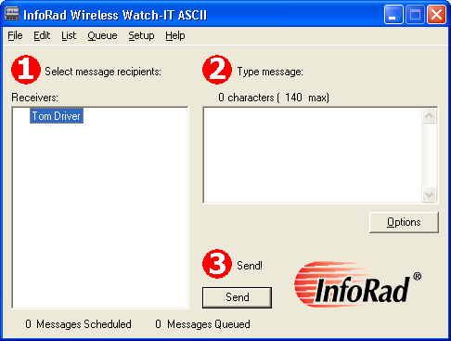

Check that the Receivers match under your InfoRad software and the Dispatch Screen in your CST software:

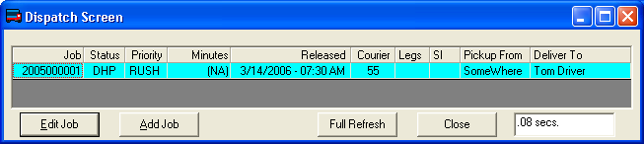

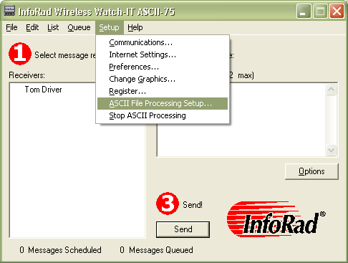
Next, we need to configure the InfoRad software so that it knows where the files are created (by your CST software). Here’s how:

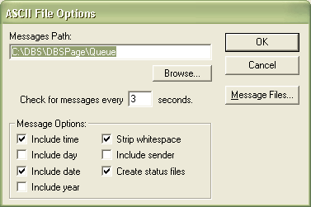
The messages path shown to the left “C:\DBS\DBSPage\Queue” is necessary. You may also have to create this directory manually if it does no already exist in Windows. I’ll show you how to create that directory at the end of this document. So for now, continue through the steps making the InfoRad software look exactly like the pictures shown.
A word about “Strip whitespace”:

You may want to try this option in both the “on” and “off” positions. Turn this option on, send a test page to your pager or cell phone. Make sure the message is readable at the pager or cell phone. If not, then turn the “Strip whitespace” option off. This feature should help one way or the other.
Don’t Click OK yet, you need to click on the “Message Files…” button to finish up.
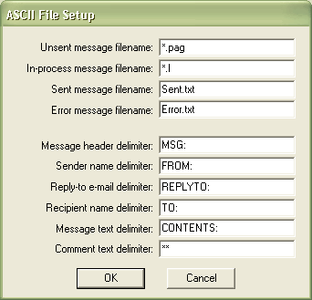
Enter the information shown here so that InfoRad software recognizes the files created by your CST software.
Once you have this setup, make sure to click OK for everything. The InfoRad should now be ready to send messages for your CST software.
However, like I stated above, you may need to create the folder(s) for your CST software.

- First, check to see if the folder exists
  - In Windows, Click Start
  - Click Run
  - Type “explorer”
  - Press enter on the keyboard
  - Copy “C:\DBS\DBSPage\Queue” into your address bar at the top (shown below)

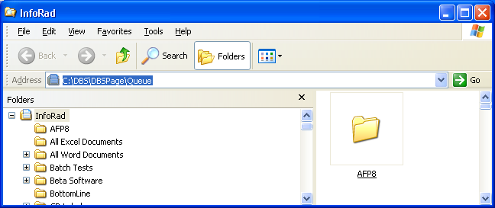

  - Press enter

Continue below…

If you see this error message, then you will need to create the folder(s) as shown below:

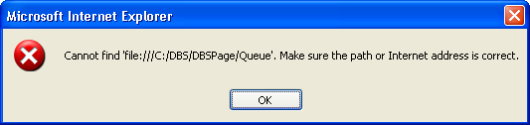

The folders that should already exist are “C:\DBS”. So enter that in your address bar as shown:

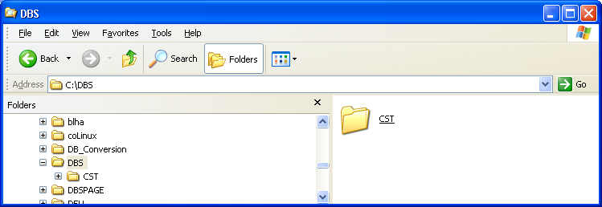

Now, follow these steps to create a new folder:

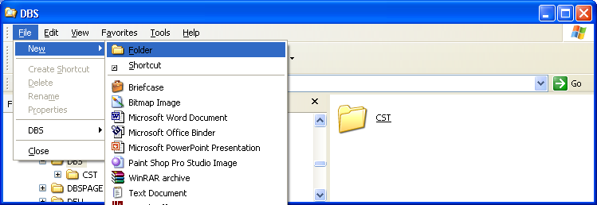

Name the folder “DBSPage”

Then, double click on the DBSPage folder to go into it.

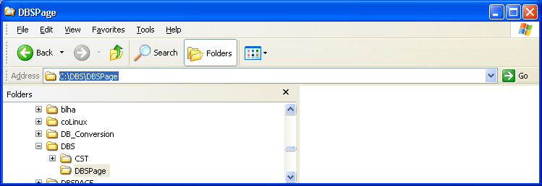

Create another new folder called Queue:

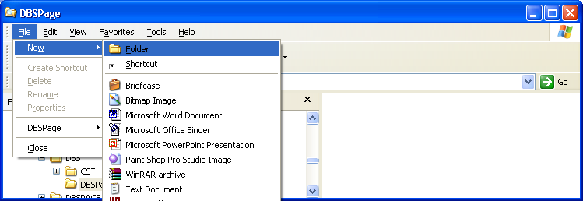

Again, name the folder “Queue”

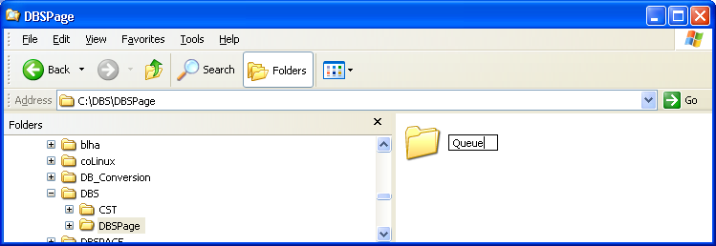

For a check, double click on it to go into it. Your address bar at the top should then read:
C:\DBS\DBSPage\Queue
Your CST software and your InfoRad software should now be setup and configured to send text messages.

If there are any further questions or concerns, please do not hesitate to contact us by sending an email to techsupport@inforad.com or call us at (800) 228-8998 and press 2 for tech support.

Thank You,

Creighton Ryan, A.A.S.
InfoRad Tech Support

